**Used car market analysis using online visualization tools**

Malarvizhi Shanmuga Pandian

-------------------------------------------------------------------------------------------------------------------------------

**Online Visualization Tools Analysis**

Out of many online visualization tools available online three tools are selected for detailed analysis on each. The tools in consideration are as follows:

* Datawrapper
* Flourish
* Kepler.gl

**Datawrapper**

Datawrapper is a Berlin based startup founded by former employees from top tier firms from different industries. There is also another service provided by them called Datawrapper River, which can be used to share and exchange data and graphs, which is suitable for collaborative work among teams.

**Positive attributes:**

1. Very straight forward steps in visualizing data
2. Supports 19 different graphs in free version
3. Color blindness check available
4. Option to publish or embed graphs online
5. Provides copyright to our creations
6. Allow visualization without creating account

**Negative attributes:**

1. Not responding well for large amount of data upload
2. Watermark still appears for free version
3. Free version allows you to download graphs only few times
4. More than allowed free version, only we need to screenshot the graph or print the webpage.

**Flourish**

Flourish is a data visualization tool created by community of developers and launched in 2018. It is part of the parent company called Canva, which is launched in 2013. Canva concentrates on providing designing solutions for business and personal needs, whereas Flourish concentrates only on visualization techniques.

**Positive attributes:**

1. Variety of graphs and various options available to customize
2. Continuous addition of graphs based on current trend
3. Ability to create audio-based stories along with visualization
4. Provides support in many languages
5. Supports different devices like mobile, laptop, and tablets
6. Exporting and embedding graphs online available
7. Connecting to live data source or API integration is possible

**Negative attributes:**

1. Free edition does not allow many features like custom theme creation

**Kepler.gl**

Kepler is a visualization tool created by Uber. It is used mainly for visualizing geospatial data in very creative ways. It is built on top of [deck.gl](https://deck.gl/), another framework for visual exploratory data analysis

**Positive attributes:**

1. Creative ideas to visualize using maps
2. Ability to develop using Python code in Jupyter notebook
3. Many customizing options available like creating layers and filters
4. Accepts CSV, GeoJSON, [Pandas](https://www.analyticsvidhya.com/blog/2016/01/12-pandas-techniques-python-data-manipulation/), and geopandas dataframe
5. Multiple exporting option available

**Negative attributes:**

1. To use some advanced options in web version, training guide is needed
2. Having knowledge on python and git integration is recommended

**Why these tools and not other online tools?**

The above selected tools – Datawrapper, Flourish and Kepler.gl all seems to have advanced options and more options to provide than other tools in the list. These tools allow free user to use most of the features that they offer in enterprise versions. Extensive references and user guides are available for these tools. Other tools like Infogram and Datamatic are only providing basic graphs and less reference materials. Rawgraph also is a great tool that caters users with variety of graphs.

**Use case – Used cars market analysis across United States:**

Current economic situation, market inflation is persistent and therefore there is increase in cost of many essentials. Few of the markets that are affected by post-covid inflation are housing market, house rental market, automobile market (both new and used), every day essentials, etc. and this is seen all over USA.

In the below analysis, the market variation with respect to used car is analyzed in detailed. The dataset is derived from craigslist listings from the year 2019 till 2022. The variation in price of the car for different car models, size, odometer reading and few other data in every state, is expected to learn from further analysis.

**Tools selected for analysis and why?**

Flourish – because it has very easy to use way and many graph customizable options that I am able to use in just clicks. Able to change graphs and se after the data is populated.

Kepler.gl – as it is the best option to visualize geospatial data and the dataset consist of regional data along with latitude and longitude.

Both will be great choice to visualize different aspects of the same data.

**How is price varying with respect to odometer readings of the care?**

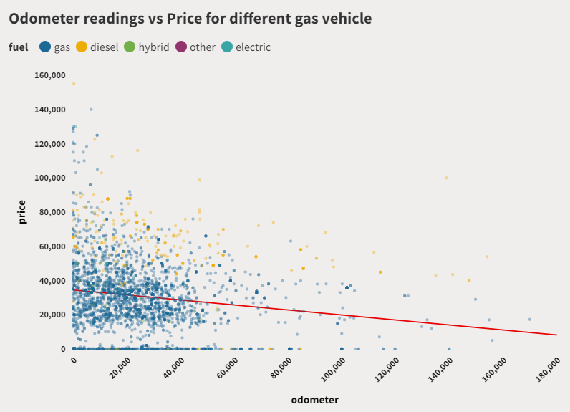

The red line denotes the overall trend of values between odometer reading and the price. It is clearly seen that the price decreases with increase in more miles driven. The color of the dot denotes the gas type of the car. Most of the cars are using gas and diesel predominantly, but there are vehicles with hybrid model and fully electric too. It’s seen that the diesel car is sold for more price than the gas car for the same miles driven.

**How many cars sold and what price range in each region of USA?**

The below graph plotted using kepler.gl shows the price range of each car in the dataset. Every dot denotes a car sold in that region. From the graph it is seen that in NYC, Boston, Jersey City, Florida, San Fransisco and San Diego are marked with more number of cars. In every place there are cars in all ranges. This maybe due the others factors like size and type of vehicles too.

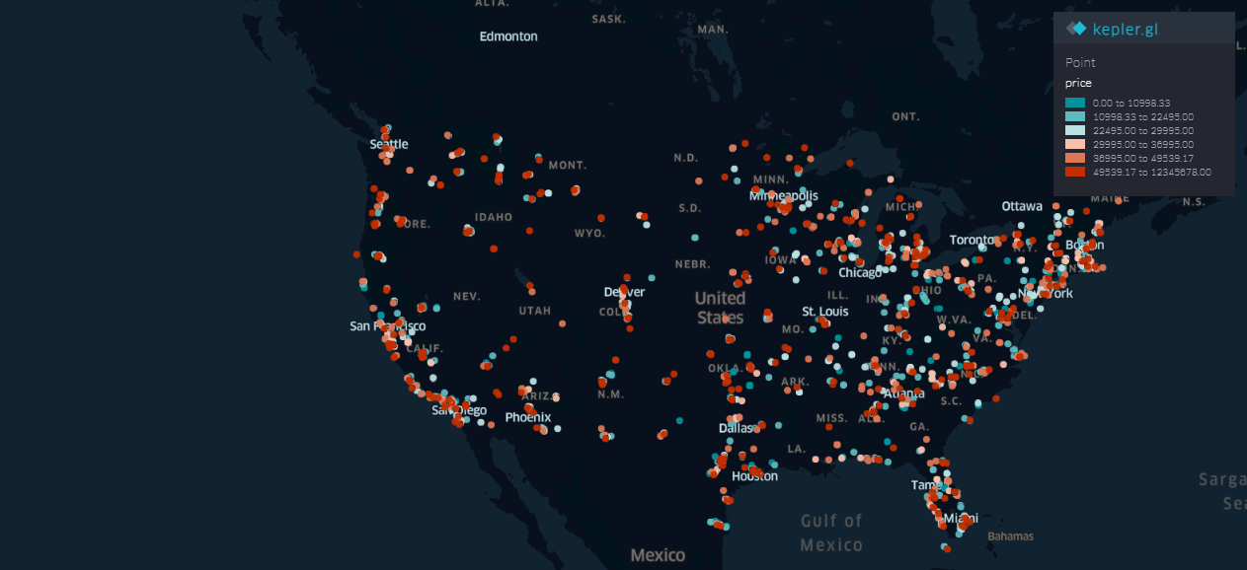

**Conclusion:**

The new car price is keep increasing currently, and main the reason is said to be the decrease in chip supply. Thus, paving a way to increase in demand for used car market. The above analysis is made for the years 2019 till present based on craigslist. Now, an overall idea about the price change based on few other factors and the demand in particular areas alone. But, more detailed analysis can be conducted in the future with the same data to visualize and compare to understand how other factors like type of vehicle, brand of car, etc. are also take into consideration while listing the car price.